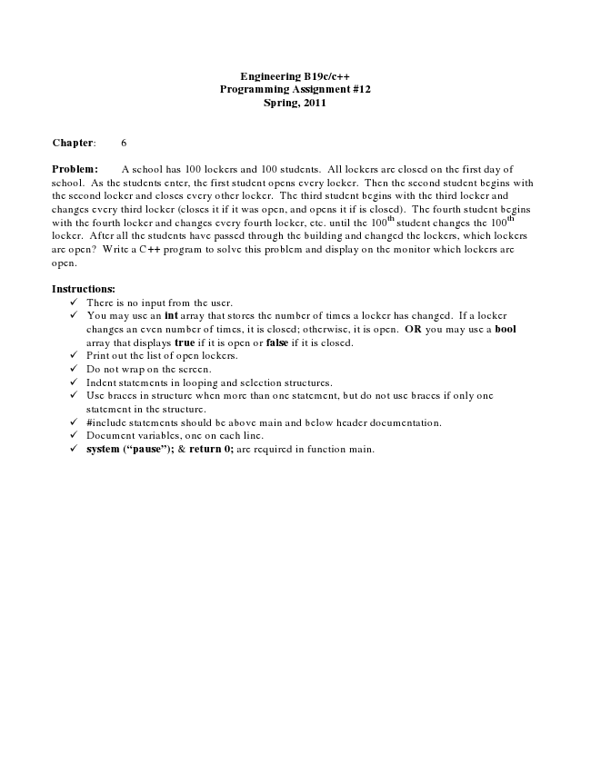

**Engineering B19c/c++ Programming Assignment #12 Spring, 2011**

**Chapter: 6**

Problem: A school has 100 lockers and 100 students. All lockers are closed on the first day of school. As the students enter, the first student opens every locker. Then the second student begins with the second locker and closes every other locker. The third student begins with the third locker and changes every third locker (closes it if it was open, and opens it if is closed). The fourth student begins with the fourth locker and changes every fourth locker, etc. until the 100

th

student changes the 100

th locker. After all the students have passed through the building and changed the lockers, which lockers are open? Write a C++ program to solve this problem and display on the monitor which lockers are open.

**Instructions:**

✓ There is no input from the user. ✓ You may use an int array that stores the number of times a locker has changed. If a locker

changes an even number of times, it is closed; otherwise, it is open. OR you may use a bool array that displays true if it is open or false if it is closed. ✓ Print out the list of open lockers. ✓ Do not wrap on the screen. ✓ Indent statements in looping and selection structures. ✓ Use braces in structure when more than one statement, but do not use braces if only one

statement in the structure. ✓ #include statements should be above main and below header documentation. ✓ Document variables, one on each line. ✓ system (“pause”); & return 0; are required in function main.